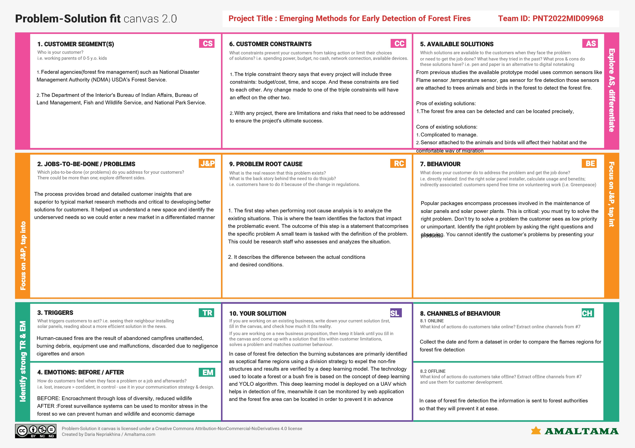

Team ID; PNT2022MID35327